

EXOR

Maintenance Manager Upgrade Guide

v4.6.1.0

Document Version History
Version | Owner | Source | Date | Description
1.0.0 | Chris Baugh | Author | 14 Jan 2013 | Initial Draft
For review: |  |  |  | For approval:

Table of Contents
1. About this Document 2
1.1 Authors 2
1.2 Document Summary 2
1.3 Reference documents 2
1.4 Distribution 2
2. Introduction 2
2.1 Purpose 2
2.2 Pre-Requisites to Upgrade 2
3. Implementation of the Maintenance Manager Software files 4
4. Maintenance Manager Server Install/Upgrade 4
4.1 Before you Start 4
4.2 Typical problems that you may encounter 4
4.3 Upgrade of Maintenance Manager 5
4.4 Mandatory Configuration (Post Upgrade) 6
4.5 Additional Configuration (Post Upgrade) 6
4.6 Spatial Configuration (Post Upgrade) 6

About this Document

Authors
- Bentley Development

Document Summary
This guide covers steps involved in upgrading the components for Maintenance Manager.

Reference documents

Distribution
Bentley/Exor Customers, Partners and Colleagues

Introduction

Purpose
This guide covers steps involved in upgrading the components for Maintenance Manager. Each product upgrade is split into two distinct stages,
- Stage 1 – Implementation of the Software files
- Stage 2 – Installation/Upgrade of the Server

Pre-Requisites to Upgrade
It is assumed that the audience of this document understand the configuration of the servers being upgraded and are sufficiently proficient with SQL*Plus. It is also assumed that the terminology used in this document is understood by the reader.
NB. The instructions for installation of the software describe the installation of all the software into a single area (usually referred to as the ‘Client’). The instructions for installing/upgrading the Server (your Highways schema) assume you have access to the database from the ‘Client’.
Your configuration and server access may differ from this. For example, you may have to install the Client software on the Application Server and the Server software on the Database Server for reasons of database access availability from the Application Server.
If in any doubt please raise a ticket at http://selectservices.bentley.com.
Before attempting to upgrade, you should ensure that:
- Network Manager v4.6.0.0 fix 2 has been applied

- The appropriate software components are installed and are compatible with the Bentley-Exor certification matrix. The certification matrix can be downloaded from the Client area of the Exor website.

- All users are disconnected from the system

- The highways listener processes are not running on the application server

- A database backup of the owner of Highways owner has been taken.

- When naming the <exor_base> directory and sub-directory structure (as discussed below) please ensure that the directory/folder string DOES NOT contain spaces.

- You MUST rename the current <exor_base> directory and sub-directory structure and contents to a new area (e.g. <exor_base4610>). This ensures that a copy is available for backup or reference purposes should any issues arise during the installation.
The installation can then continue into the area that the <exor_base> normally resides (which should now be empty).
For Example:
….rename the current <exor_base> directory and sub-directory structure and contents to a new area (e.g. <exor_base4610>)
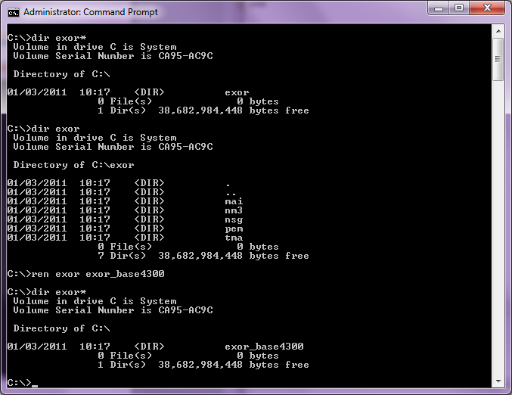

… The installation can then continue into a clean area (e.g. c:\exor) by unzipping the release zip file. This will create a folder/directory structure with the release files which will be used to install or upgrade your system.

Implementation of the Maintenance Manager Software files
To install the software components for Maintenance Manager first check that the MAI folder is present and correctly unzipped from the release zip file.

Important:
All Exor applications that you install must go into the same destination – what is often referred to as <exor_base>.

Maintenance Manager Server Install/Upgrade
This chapter provides details of steps involved in upgrading the server components for Maintenance Manager.

Before you Start
Before proceeding please ensure that the pre-requisites mentioned in Pre-Requisites to Upgrade of this document are met.
Also, please be aware of the following:
- Where an upgrade is to be performed please ensure that any data loading being done through the Maintenance Manager loader modules has been completed, any data held in the Maintenance Manager load tables may be removed during this upgrade.

- Where instructed to change to a directory before running a script, it is assumed that you are running SQL*PLUS from a DOS Command prompt.

- If you are running SQL*PLUS in windows you should set the 'start in' directory of the SQL*PLUS shortcut to simulate the change of directory.

- If you do not run SQL*PLUS from the directory stated in each step of the guide, the installation will fail.

- Also, whilst following the instructions in this section you will be required to know the location of <exor_base>. You may recall that whilst undertaking the tasks in the previous subsection you will have implemented software into the location referred to as <exor_base>, for example, C:\EXOR.

Typical problems that you may encounter
It is possible that, when you are running some of the upgrade scripts, errors may be reported saying that objects already exist in the database or that columns already exist on tables. These errors can generally be ignored. If you are in any doubt, please contact the Exor support desk for guidance.
The upgrade procedures will also attempt to install database roles in the highways owner account that are necessary for the system to operate correctly. You may find that errors are produced when running the upgrade scripts to the effect that the role names being created are already used by existing roles or users. These errors can be ignored as they simply mean that the roles being created already exist.

Also during install/upgrade Warning messages may appear saying that compilation errors have occurred. These warnings can be ignored, since invalid objects will be recompiled prompt later on in the install/upgrade. However it will be of concern if compilation errors still occur following the re-compilation.

Upgrade of Maintenance Manager
This section describes the steps necessary to upgrade Maintenance Manager to 4.6.1.0

To upgrade the base data and objects for the Maintenance Manager modules;
- Change directory to <exor_base>\mai\install

- Login to SQL*PLUS as the highways owner on the client PC

- Run the following command
start mai4600_mai4610.sql

- You will be prompted to enter the path of the location of your highways software. This should be name of the directory, including disk identifier and a trailing slash character, referred to as <exor_base>.

For example, if you installed your highways software in a directory called EXOR on your C drive, you would enter the following when prompted.
C:\EXOR\
- When you have supplied this value, you will be prompted to confirm that it is correct and asked whether you wish to continue.

- If the value specified is not correct or does not end with a slash character, you will be given an error message and the installation script will abort. You will then need to login to SQL*PLUS again and rerun the script.

- When the script has completed, all the Maintenance Manager objects and data will have been upgraded.

Checking Log File(s)
The following log files are produced in the working directory. At the end of the upgrade, they can be viewed to check for any errors that could have occurred during the upgrade process.

mai4600_mai4610_1_<date&time>.LOG
mai4600_mai4610_2_<date&time>.LOG

Please raise and attach the logs to a ticket with http://selectservices.bentley.com to allow Bentley (formerly exor) support staff to verify the upgrade has been successful.
Due to interdependencies between some Exor products, please ignore all compilation errors until all of your products have been upgraded.

Mandatory Configuration (Post Upgrade)

exor_version.txt
Before accessing Maintenance Manager you must check the file exor_version.txt.
This file is referenced in Windows Registry setting ‘EXOR_VERSION’ and by default can be located in the <exor_base>\bin directory.
Ensure that the entry for Maintenance Manager is set accordingly;
MAI=4.6.1.0

Additional Configuration (Post Upgrade)
Consult the documentation that accompanies this release for details of any additional configuration that may be required following an install/upgrade.
For example, to obtain details of product options, and for details of new product features/amendments.

Important:
It is highly recommended that you do this before attempting to use the application.

Spatial Configuration (Post Upgrade)
Specific information regarding the registration of spatial layers can be found in the “Locator and Web Mapping” document.

